Pokhara University

Level: Bachelor | Semester – Spring | Year : 2006
Programme: BE |  | Full Marks: 100
Course: Control System |  | Time : 3hrs.

Candidates are required to give their answers in their own words as far as practicable.
The figures in the margin indicate full marks.

Attempt all the questions.

 | - Draw the mechanical network, F-V analogus and F-I analogus circuit of the system below.  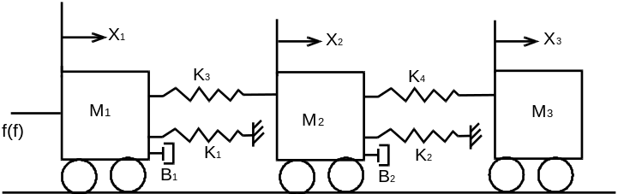  - State the Mason’s gain formula and using the method of reduction determine the ratio of c(s)/R(s) form the given block diagram.  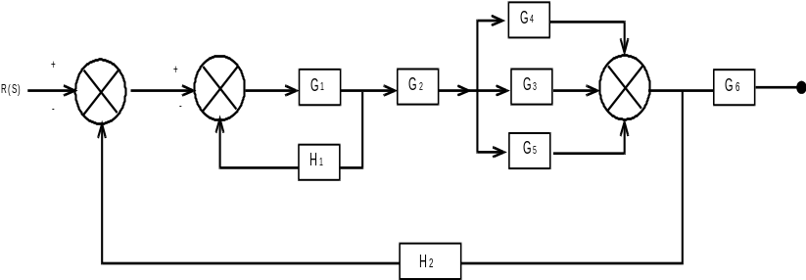 | 8  7
 | - Determine the transfer matrix G(s) for the system having following parameter.  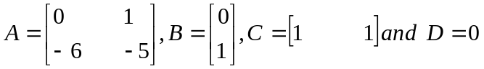  - Apply Routh criterion to determine the stability of the system having the characteristics equations as 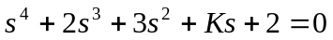  - The open loop transfer function of a unity feedback system is given by 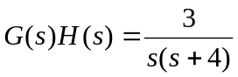. Obtain the time response of the system when subjected to a unit step input. | 5  5  5
 | - Draw the block diagram of armature controlled d.c motot and find out its transfer function if angular displacement of the motor shaft is considered as output and supply voltage as an input.  - The forward path transfer function of a unity feedback control system is G(S)=200/S(S+5). Determine the steady state error for input r(t) = 1+2t + t².  - Differentiate between open loop and closed loop system. | 5  5  5
 | Draw the Root locus for 0<K<∞ for system with open-loop transfer function.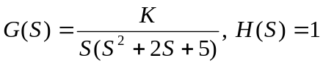 | 15
 | - Sketch the Nyquist diagram for the system with open loop transfer function given by: 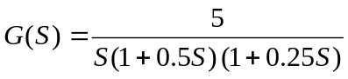. Examine the stability of this system from this diagram.  - Draw the Bode plot for the open loop transfer function given by: 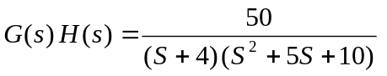. Also determine gain margin and phase margin from the Bode plot. | 7  8
 | The forward path transfer function of a control system is given by: 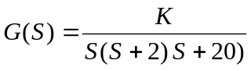 Design a suitable lag compensator having  - Phase margin >35º  - Kv = 20sec^{–1} | 15
 | Write short notes on (Any Two):  - Effect of positive feedback on stability  - Frequency domain specification  - Effect of adding poles and zeros on transfer function | 5×2

